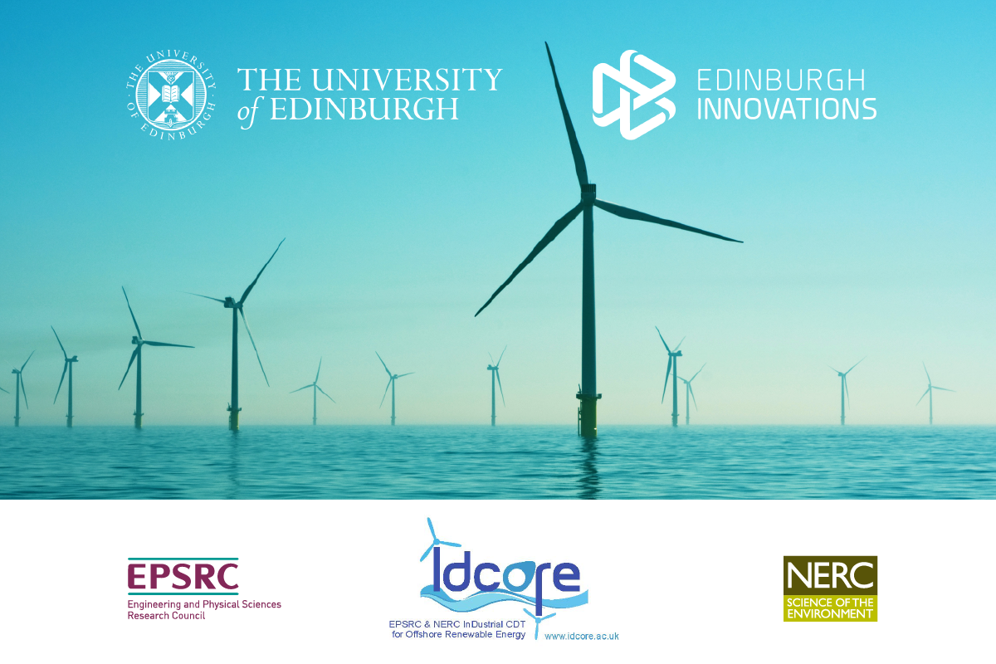

IDCORE: Student Project Application 2022

Company Sponsor
Name of company

Project Title

Company Representative
Please provide full job title and contact details

Company Background
Please provide details of the company and its interests

Project Background
Please provide details of the problem or opportunity the project seeks to address

Project Objectives
Please provide details of the research and project objectives

Please submit by Friday 13th January 2023 to andrew.aveyard@ei.ed.ac.uk

